Lab Session – Day 10

**Question:**

Use classicmodels. Create a view territory_status mentioning the details about no. of employees in each territory.

Tables to be used: Offices, Employees

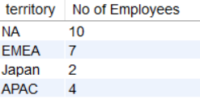The output should look as shown in below image.

**Solution:**

Write the below query in MySQL workbench.

